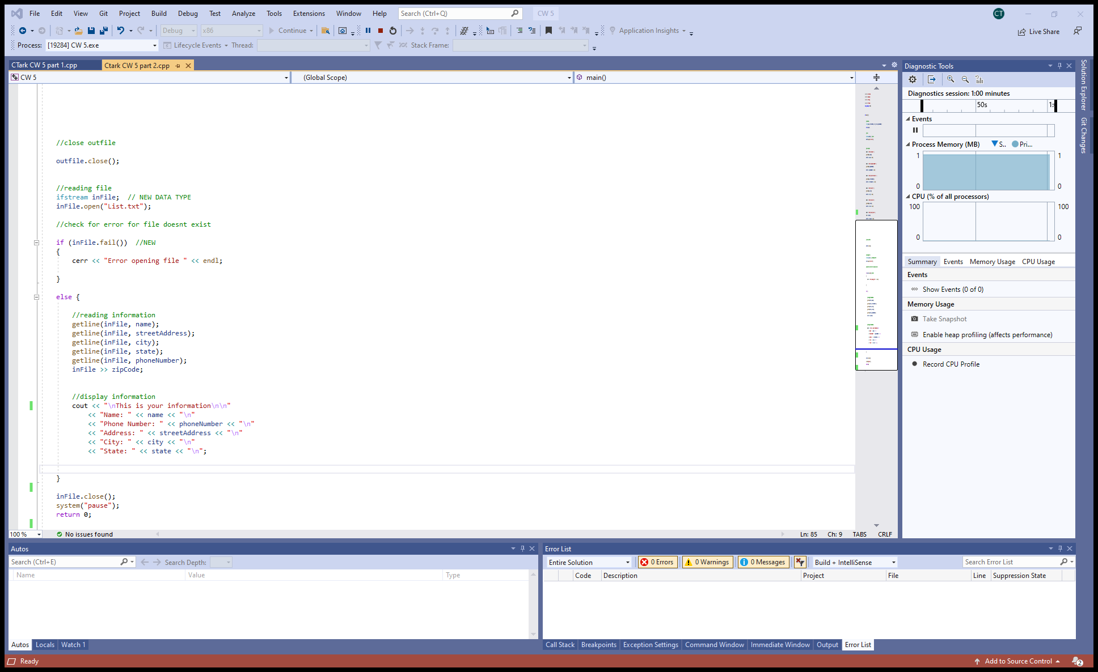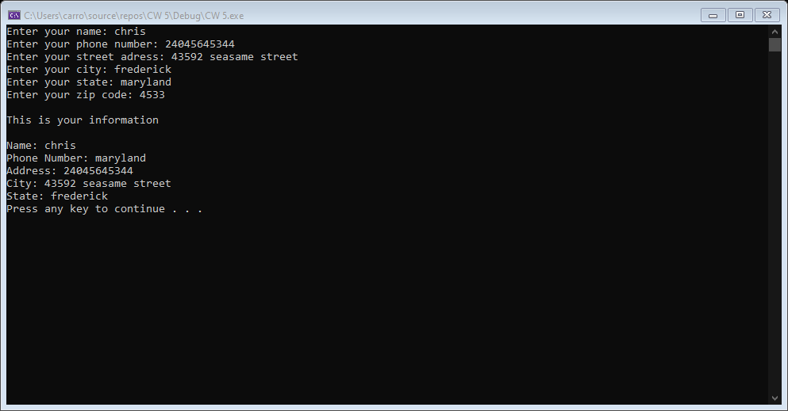

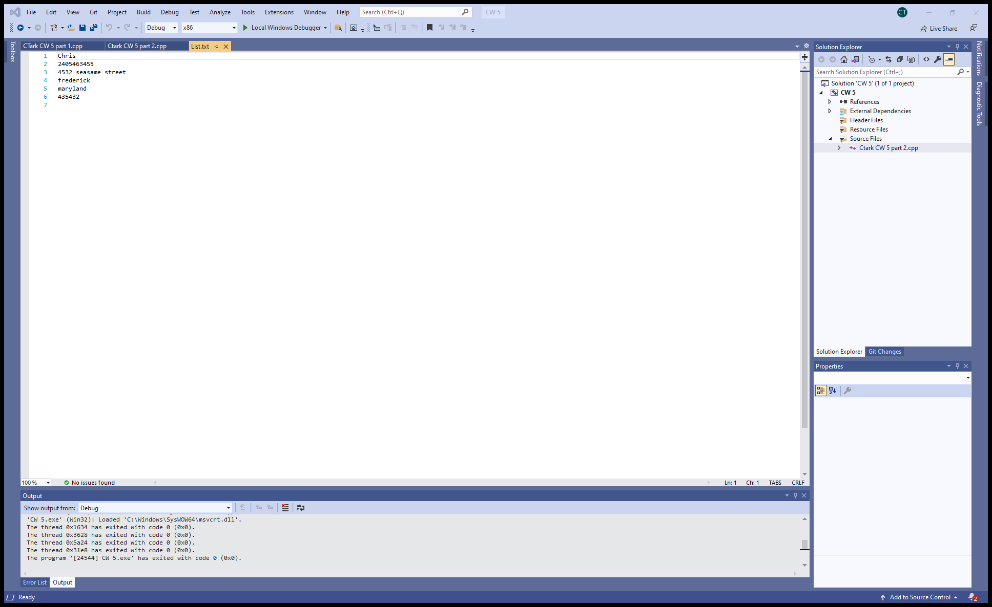

#include <iostream>

#include <iomanip>

#include <string>

#include <fstream>

using namespace std;

int main() {

//varibles

string name, streetAddress, city, state, phoneNumber;

int zipCode;

//file

ofstream outfile; // NEW

outfile.open("List.txt");

//user input

cout << "Enter your name: ";

getline(cin, name);

outfile << name << endl;

cout << "Enter your phone number: ";

getline(cin, phoneNumber);

outfile << phoneNumber << endl;

cout << "Enter your street adress: ";

getline(cin, streetAddress);

outfile << streetAddress << endl;

cout << "Enter your city: ";

getline(cin, city);

outfile << city << endl;

cout << "Enter your state: ";

getline(cin, state);

outfile << state << endl;

cout << "Enter your zip code: ";

cin >> zipCode;

outfile << zipCode << endl;

//close outfile

outfile.close();

//reading file

ifstream inFile; // NEW DATA TYPE

inFile.open("List.txt");

//check for error for file doesnt exist

if (inFile.fail()) //NEW

{

cerr << "Error opening file " << endl;

}

else {

//reading information

getline(inFile, name);

getline(inFile, streetAddress);

getline(inFile, city);

getline(inFile, state);

getline(inFile, phoneNumber);

inFile >> zipCode;

//display information

cout << "\nThis is your information\n\n"

<< "Name: " << name << "\n"

<< "Phone Number: " << phoneNumber << "\n"

<< "Address: " << streetAddress << "\n"

<< "City: " << city << "\n"

<< "State: " << state << "\n";

}

inFile.close();

system("pause");

return 0;

}